Mahboob Medical Institute – Peshawar

Organization for Relief, Rehabilitation and Higher Education
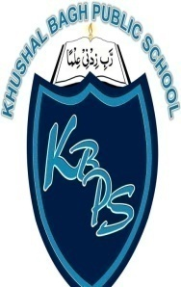
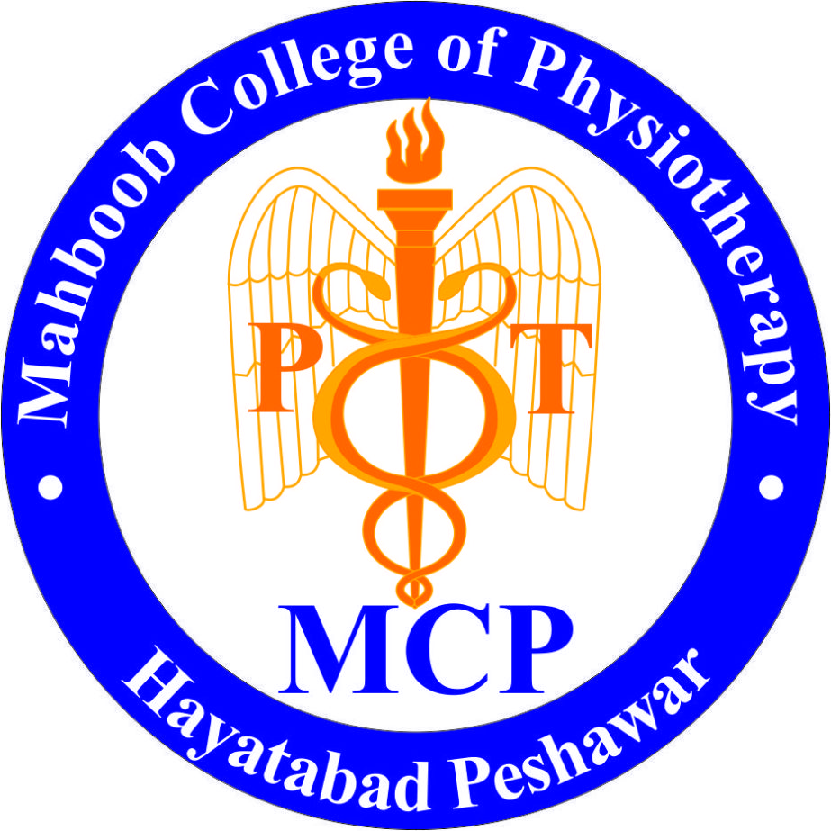
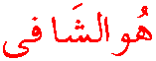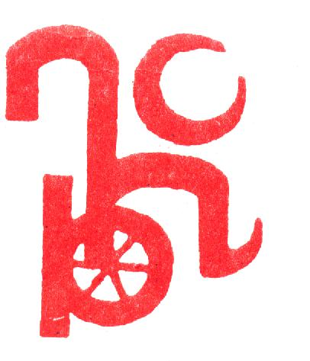

Habib Physiotherapy Complex
Comprehensive Rehab Centre

Mahboob College of
Physiotherapy

Khushal Bagh Public School
Inclusive Education for Special Children

Annual Report on the Habib Foundation activities and achievements in 2017

Habib Physiotherapy Complex
Sector B – 2, Phase – 5, Hayatabad – Peshawar (Pakistan)

Contacts; + 92 91 581 9128; + 92 300 859 3184

Email mahboobhpc@gmail.com Website www.hpcpk.org
Chairman's Introduction

It is my pleasure to introduce this year again the Annual Report on the activities and achievements of the Habib Foundation. It has been our mission to promote and advance progress in all fields of Physiotherapy ad do our best efforts to achieve excellence in all the departments. Our efforts will lead to improve social prosperity in terms of our OPD patients in Habib Medical Complex and providing quality education and facilities to our students so they can excel in their life in Physiotherapy field and, and thus can function and excel in international market.
I am proud to present our achievements and success in 2017. Excellence in each department is our basic criteria. We will keep our focus to progress more in the coming years Insha’Allah not only to help our local community in Physiotherapy and Rehabilitation but also to expand it nationwide.
Mahboob ur Rehman
Founder and Chairman,
Habib Foundation

1.1 Rehab Services

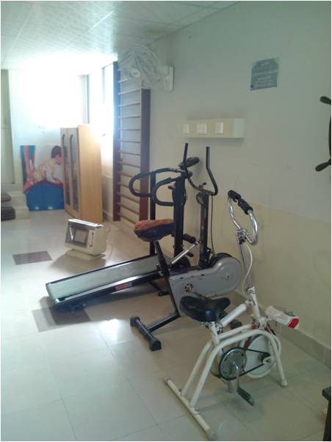
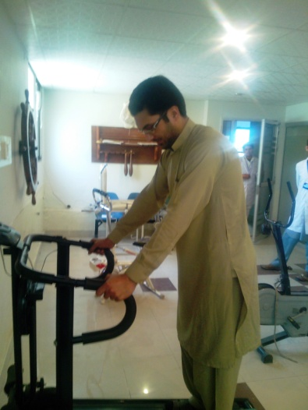
Habib Physiotherapy Complex continued its services for the Rehabilitation of Physically Disabled where indoor and outdoor patients were facilitated. The detail about the treated patients during the year 2017 is as under:

- Physiotherapy Patients Data
Period | Paid Patients | Discounted Patients | Free Treated | Total
January  to  Dec. 2017 | 2197 | 1675 | 924 | 4796

- Over-all Data
Services | Pakistani | Afghani
Physiotherapy | 4483 | 313
Appliances/Walking Aids | 178 | 2
Speech Therapy | 318 | 52
Audiology | 199 | 73

1

1.2 Free Camp
Habib Physiotherapy Complex provided volunteer services (free of cost) or on nominal rates for Local Community and Afghan Refugees. Different camps were organized during the year 2017 at Habib Physiotherapy Complex and in parts of KPK Province. A large number of patients were examined and treated free of cost and free admission and Therapeutic Regime was offered at Habib Physiotherapy Complex.
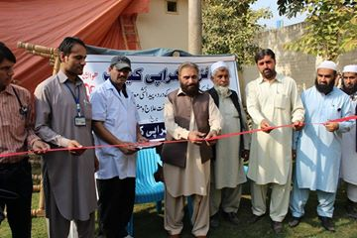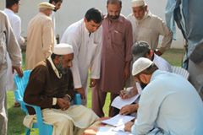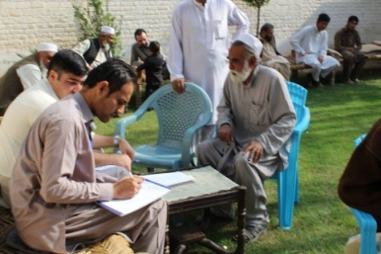
1.3 Audiometry Services
Habib Physiotherapy Complex got a specialist for audiometric patients. He treats number of patients included local and Afghans as well.
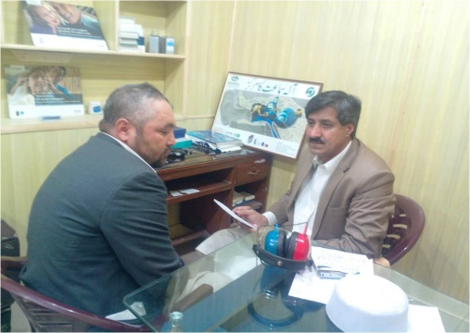
1.4 Special Children Unit
Special Children Care Unit has been started at Habib Physiotherapy Complex where C.P. children are being treated regularly.
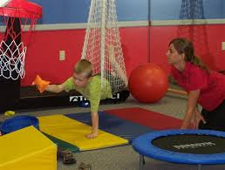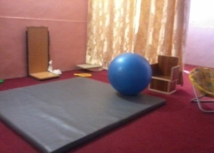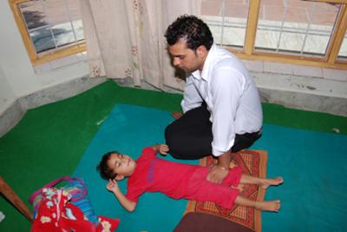

  - MoU with Services Hospital (formerly Police Hospital)
A meeting was held on 16 March 2017 where an MoU was signed with Police and Service Hospital in Honor of Dr. Mahboob ur Rahman and MS Ashoor Khan Afridi. MoU states us to work together more closely towards over common goal. Significant activities, such as promotion of educational and academic exchange between organizations, educational institutions and individual; assistants to supports study and educational opportunities of Physical Therapy training (these were all efforts of Dr. Mahboob ur Rahman that are contributed to the finalization of this MoU). Physiotherapy Training was discussed in detail as well as other important matters were also discussed and decisions were taken.
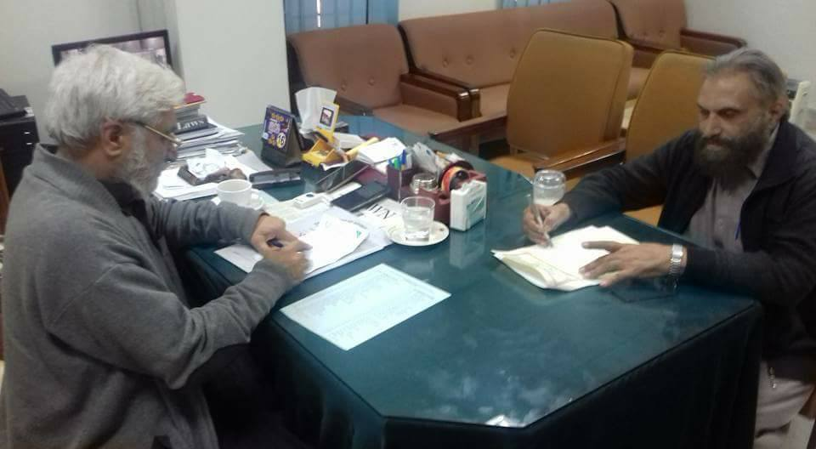

1.6 Orthopedic Workshop
Numbers of patients are getting benefit through this facility by enabling them to bring back to normal life with provision of Orthotics and Prosthetics at discounted rates. A new department of Prosthetics and Orthotics has been established with state-of-the-art equipment under the supervision of well versed skilled staff members. BS Orthotics; 4 Years course is to be planned/launched from Summer 2017.

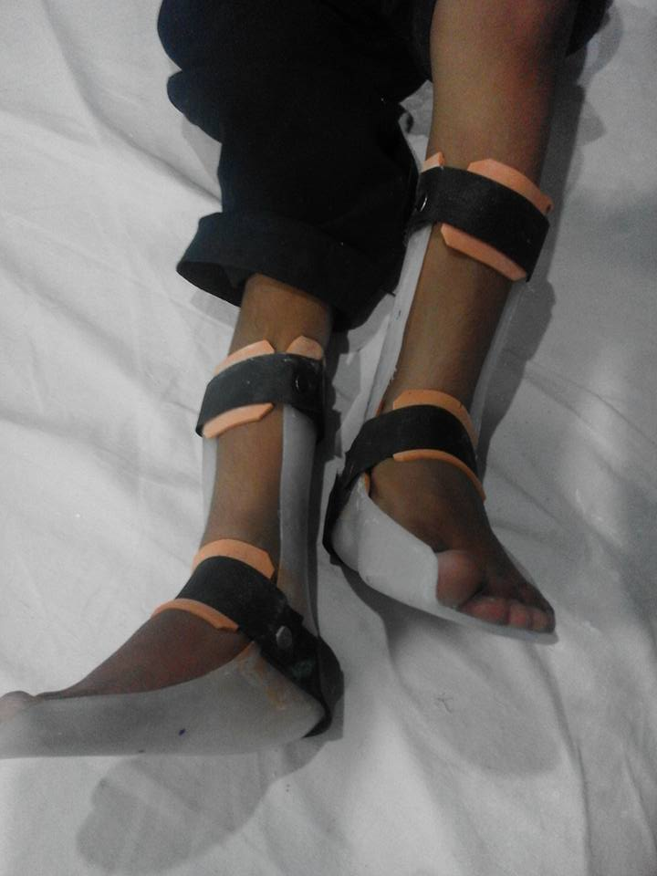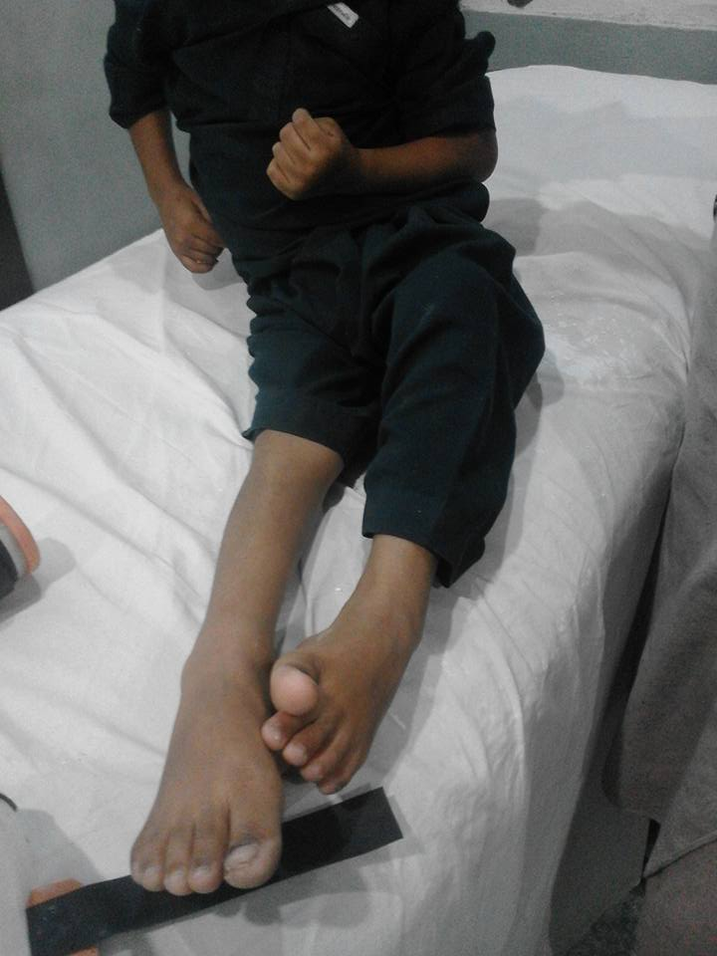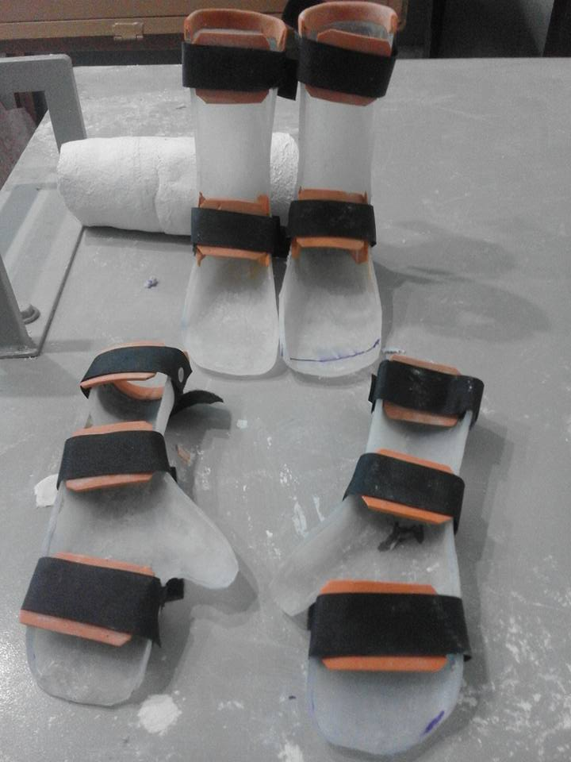

1.7 Success Story
Mr. Fayyaz; who lost his both arms due to high voltage electric shock in 2006, though he got artificial limbs from PIPOS but it was cosmetic and non-functional. As such he was dependent on his parents for feeding: taking food. We provided him simple cast type devices, where spoon and pen could be fitted and he started taking food by himself. He can write as well. The idea was given by the Chairman; Dr. Mahboob ur Rahman and Ms. Bushra Jillani made the device.
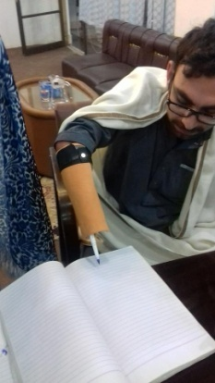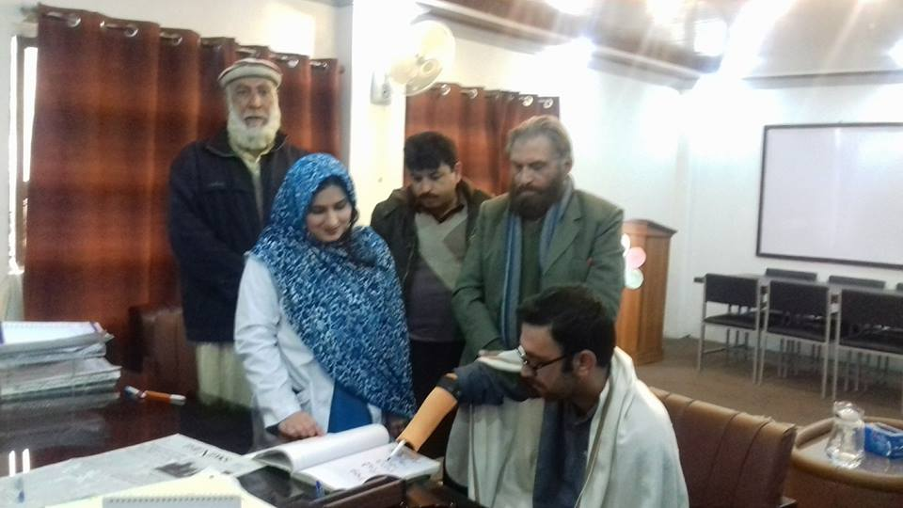

2.1 Blood Donation Camp
A Blood Donation Camp was arranged by the Mahboob Medical Institute Management with collaboration of Regional Blood Centre, Hayatabad Peshawar, where number of students and faculty members participated very actively.

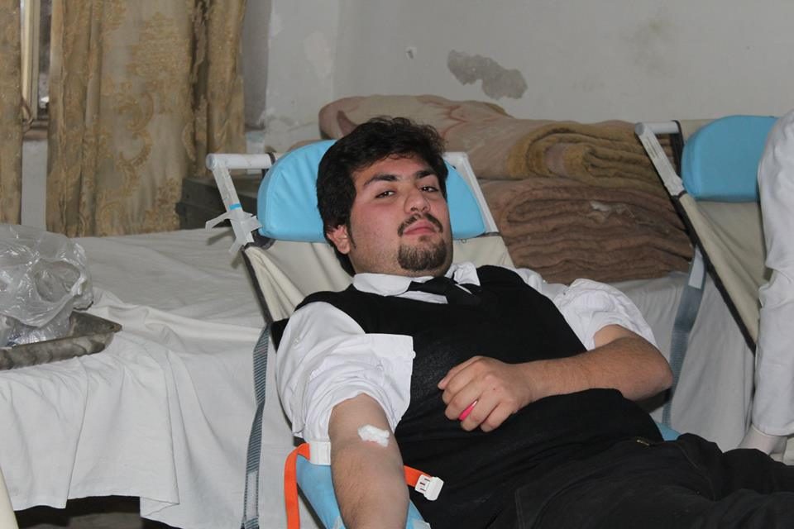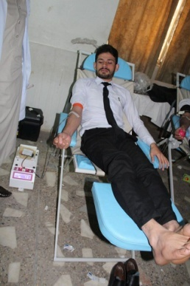

2.2 One Day Seminar – How to write Scientific Research Paper
One Day Seminar was organized for the Faculty Members and particularly for Students highlighting them about the tactics and methods how to write the Research Papers. The key-note Speaker was Prof. Khan Alam from Peshawar University who explained the things and details and the audience was largely benefited by his thoughts and ideas.

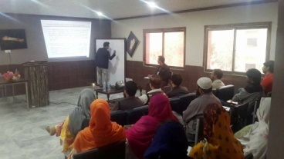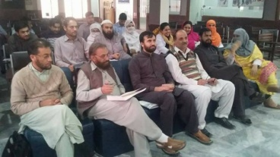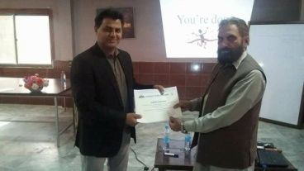

2.3 Days First-Aid Training
First-Aid Training was arranged for the students explaining them how to deal in case of any emergency with the collaboration of Pakistan Red Crescent Society where number of students participated actively by showing their interest at large. Dr. Roshan Khan was the focal person explaining First-Aid Training’s needs, benefits and importance.

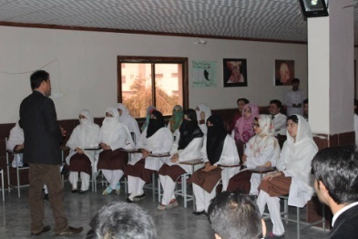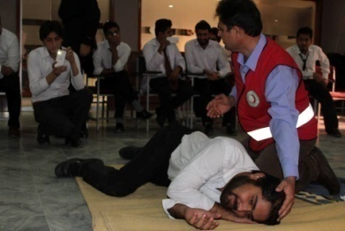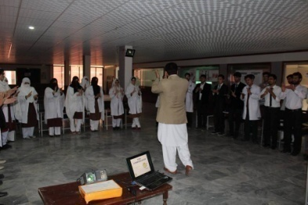

2.4 New Department of Transitional Doctor of Physiotherapy
A team consisting of Academic Experts, Administrative Body and Examination Section visited the College for new disciplines affiliation and the Management of Mahboob College of Physiotherapy feels honored to share that KMU granted permission to start Transitional Doctor of Physiotherapy (T – DPT).
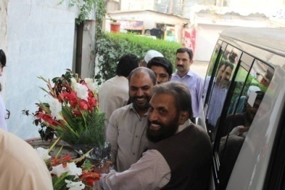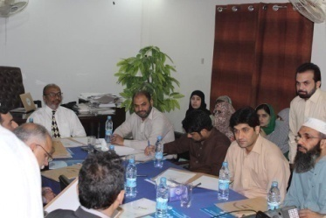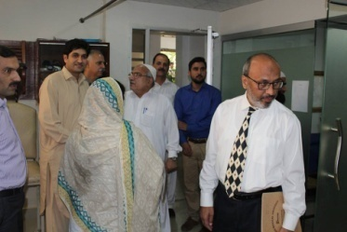

2.5 MoU signed with Akbar Kare Institute, Peshawar
As Mahboob Medical Institute has recently signed Memorandum of Understanding with Akbar Care Institute. AKI team visits Mahboob Medical Institute on 2nd March 2017. The purpose of this visit was exchange idea among honorable chairman Dr Mahboob ur Rahman and all staff members about Physical Therapy Training. During discussions they said working together in teams is suggested to be most effective way of caring for disabled community. AKI team appreciated MMI.
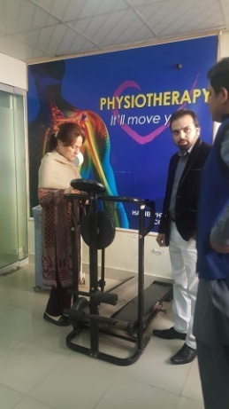
Following are the highlights of the visit:

2.6 One Day Seminar Pediatric Orthotics by Foreign Expert
An orthopedic Workshop was arranged with collaboration of ISPO and RCPD. Key-note Speaker was Mr. Shad Muhammad Khan from UAE, focusing on kids, their problems and how to settle those issues and treat them accordingly.

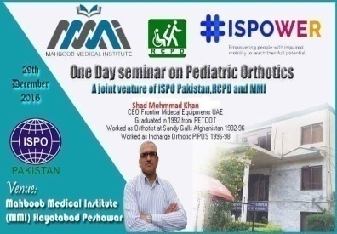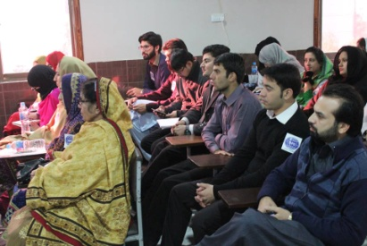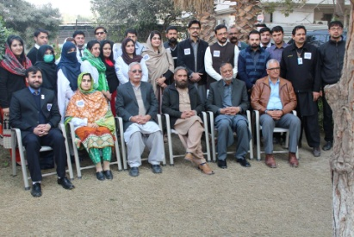
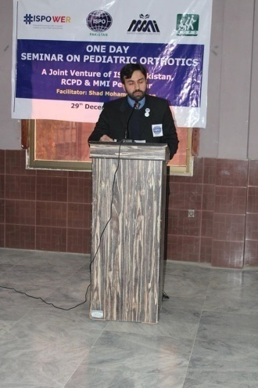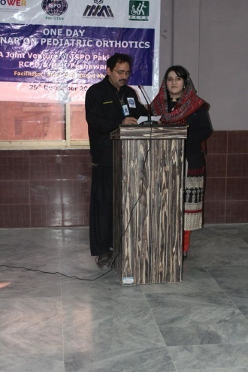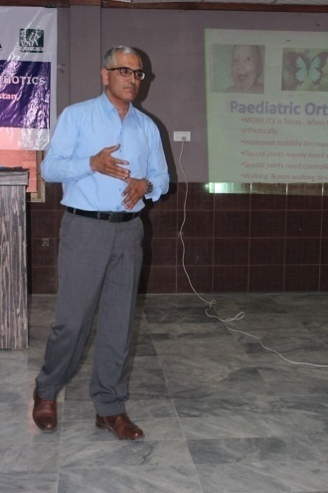
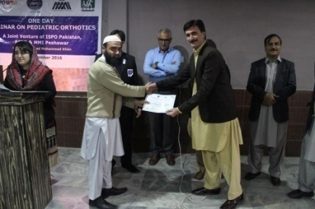

2.7 Visit by Armed Forces Institute of Rehabilitation Medicines Team
Malik Naeem Physiotherapy in charge of AFIRM had a Special meeting with Chairman Dr. Mahboob ur Rahman. Chairman warmly welcomed Malik Naeem to the MMI and took his time from the day to day routine. They claimed that welfare of the disabled community should be their top priority. Discussion about Physiotherapy was brief but healthy.
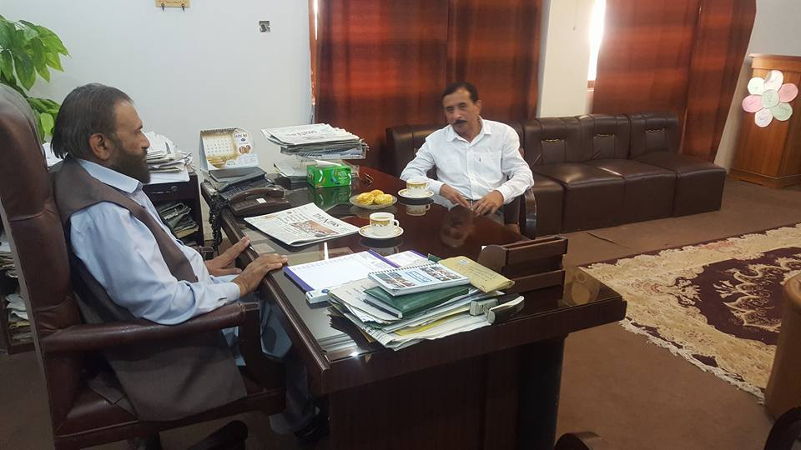

2.8 World Disability Day
3rd December – World Disability Day was observed at Mahboob Medical Institute (M. M. I.) with deep interest. Mahboob College of Physiotherapy Students participated actively through skits, speeches and presentations. The day was honored by Dr. Hafeez Ullah Khan – Vice Chancellor Gandhara University, Peshawar as Chief Guest. Students from Mahboob College of Physiotherapy, Special Education Complex and Khushal Bagh Public School participated in the event and presented different skits, national songs etc.

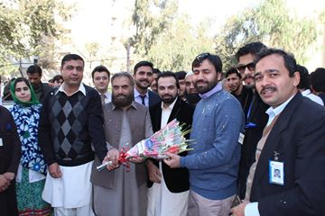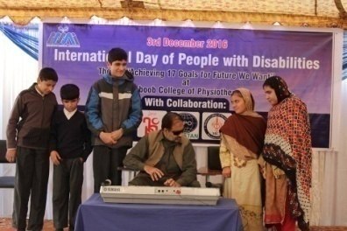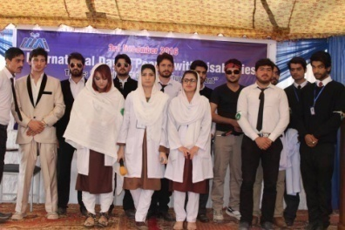
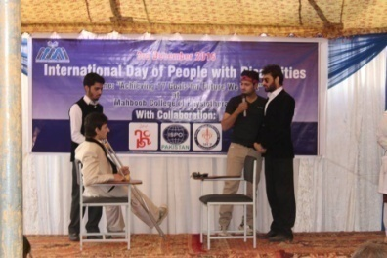

  - MILAD
Eid Milad un Nabi (SAW) was observed where the Faculty Members and Students participated with religious zeal. The interested students presented Naat Shareef and recited the Tilawat-e-Quran. At the end of this blessed event, prizes were distributed among the winners.

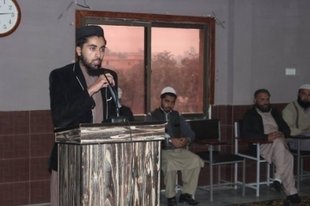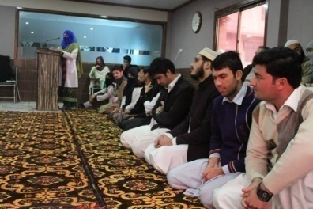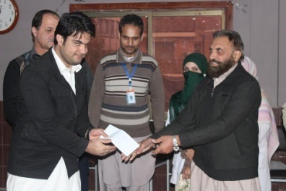

2.10 Staff Meetings
The Management Committee Meetings held fortnightly where we kept on focusing towards the betterment of the institution. Besides the meetings, we do enjoy get together as a family.
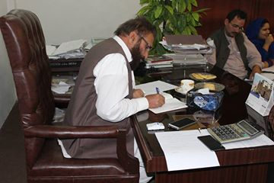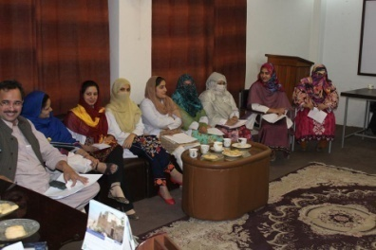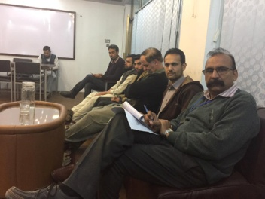
2.12 D. P. T. New Batch
New Batch Doctor of Physiotherapy – 8th Batch inducted at Mahboob College of Physiotherapy – classes started on October, 2017. Mahboob School of Physiotherapy got state-of-the-art facilities for its students having full-fledged facilitated class rooms, computer lab, library, multimedia, skill lab etc.

2.13 Trainings
Mahboob Medical Institute Peshawar signed a Memorandum of Understanding with FATA Development Authorities. We will train (20) students being sponsored by the FATA Authorities and the said course will be starting from February 2017 for 2 years. The said course is running successfully and students are learning the skills with keen interest.

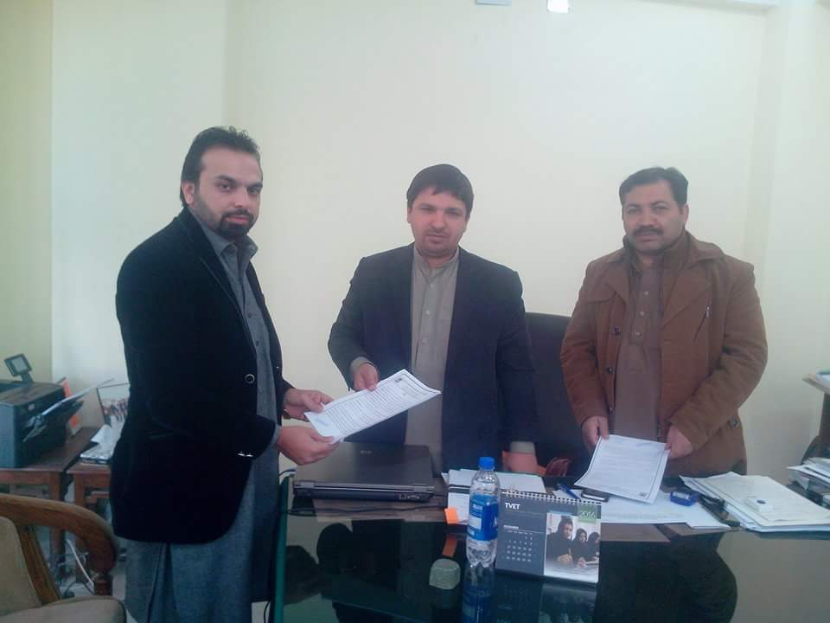

2.14 NEW DISCIPLINE – T. D. P. T.
Academic Council Khyber Medical University approved T – DPT Program to be launched at Mahboob College of Physiotherapy from January 2017. The classes started in October 2017 and running successfully.

2.15 6th Batch Passed-out
A group of 32 Students passed out their Doctor of Physiotherapy (D. P. T.) Degree with distinction.

Inclusive Educational Institute

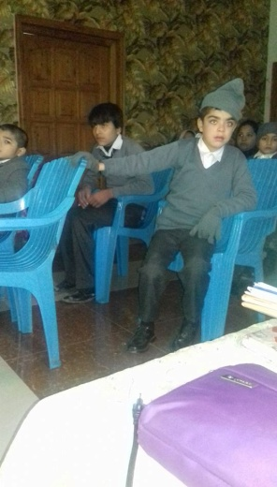
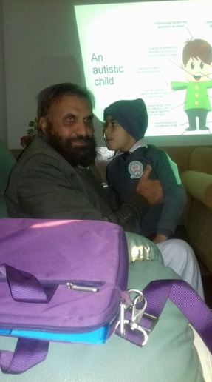
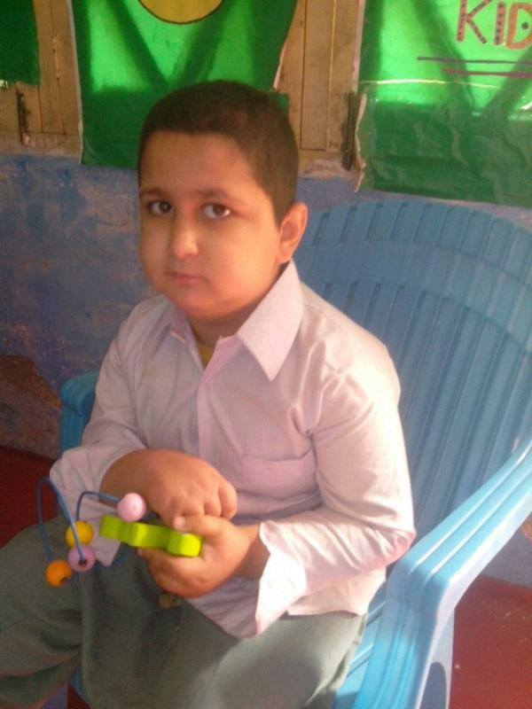
Inclusive Educational Institute at Khushal Bagh Public School has been started during the year 2017 where Special Children are taught with normal children enabling them to live like normal ones.

